**ASTABLE MULTIVIBRATOR AND VARIABLE MULTIVIBRATOR**

**Exp No: 5 Date: 24/02/2022**

**Objective:**

**To design, simulate and verify square wave generator/astable multivibrator and variable multivibrator.**

**Software Required:**

LT Spice - XVII

**Theory:**

**Op-amp Multivibrator Circuit: -**

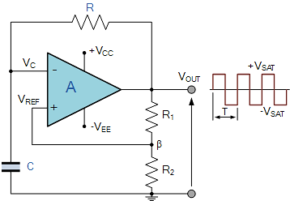

 So how does it work. Firstly, let’s assume that the capacitor is fully discharged and the output of the op-amp is saturated at the positive supply rail. The capacitor, C starts to charge up from the output voltage, VOUT through resistor, R at a rate determined by their RC time constant.

We know from our tutorials about RC circuits that the capacitor wants to charge up fully to the value of VOUT (which is +V(sat)) within five-time constants. However, as soon as the capacitors charging voltage at the op-amps inverting (-) terminal is equal to or greater than the voltage at the non-inverting terminal (the op-amps output voltage fraction divided between resistors R1 and R2), the output will change state and be driven to the opposing negative supply rail.

But the capacitor, which has been happily charging towards the positive supply rail (+V(sat)), now sees a negative voltage, -V(sat) across its plates. This sudden reversal of the output voltage causes the capacitor to discharge toward the new value of VOUT at a rate dictated again by their RC time constant.

**Op-amp Multivibrator Voltages: -**

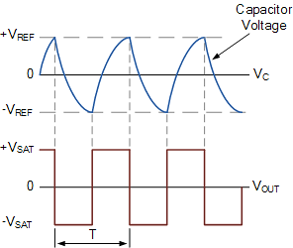

Once the op-amps inverting terminal reaches the new negative reference voltage, -VREF at the non-inverting terminal, the op-amp once again changes state and the output is driven to the opposing supply rail voltage, +V(sat). The capacitor now sees a positive voltage across its plates and the charging cycle begins again. Thus, the capacitor is constantly charging and discharging creating an astable op-amp multivibrator output.

The period of the output waveform is determined by the RC time constant of the two-timing components and the feedback ratio established by the R1, R2 voltage divider network which sets the reference voltage level. If the positive and negative values of the amplifier’s saturation voltage have the same magnitude, then t1 = t2 and the expression to give the period of oscillation becomes:

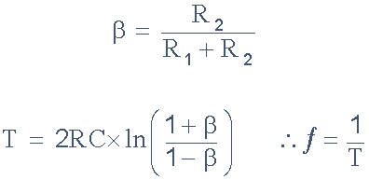

Where: R is Resistance, C is Capacitance, ln () is the Natural Logarithm of the feedback fraction, T is periodic time in seconds, and ƒ is oscillation Frequency in Hz.

Then we can see from the above equation that the frequency of oscillation for an **Op-amp Multivibrator** circuit not only depends upon the RC time constant but also upon the feedback fraction. However, if we used resistor values that gave a feedback fraction of 0.462, (β = 0.462), then the frequency of oscillation of the circuit would be equal to just 1/2RC as shown because the linear log term becomes equal to one.

**Example No1: -**

An op-amp multivibrator circuit is constructed using the following components. R1 = 35kΩ, R2 = 30kΩ, R = 50kΩ and C = 0.01uF. Calculate the circuits frequency of oscillation.

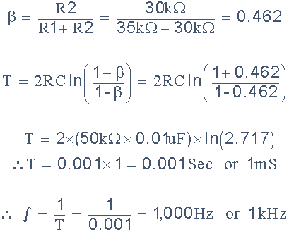

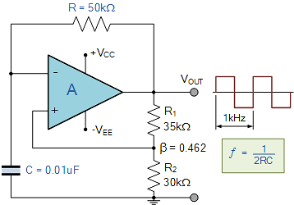

Then the frequency of oscillation is calculated as 1kHz. When β = 0.462, this frequency can be calculated directly as: ƒ = 1/2RC. Also, when the two feedback resistors are the same, that is R1 = R2, the feedback fraction is equal to 3 and the frequency of oscillation becomes: ƒ = 1/2.2RC.

We can take this op-amp multivibrator circuit one step further by replacing one of the feedback resistors with a potentiometer to produce a variable frequency op-amp multivibrator as shown.

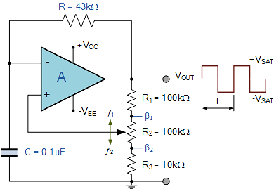

By adjusting the central potentiometer between β1 and β2 the output frequency will change by the following amounts.

**Potentiometer wiper at β1: -**

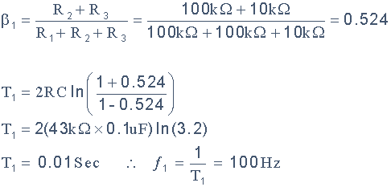

**Potentiometer wiper at β2: -**

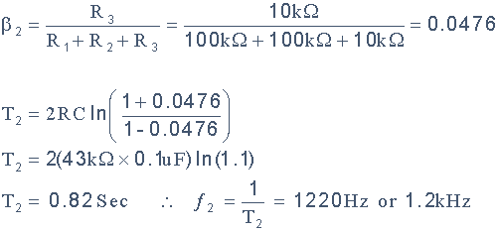

Then in this simple example we can produce an operational amplifier multivibrator circuit that can produce a variable output rectangular waveform from 100Hz to 1.2kHz, or any frequency range we require just by changing the RC component values.

We have seen above that an **Op-amp Multivibrator** circuit can be constructed using a standard operational amplifier, such as the 741, and a few additional components. This voltage controlled non-sinusoidal relaxation oscillators are generally limited to a few hundred kilo-hertz (kHz) because the op-amp does not have the required bandwidth, but nevertheless they still make excellent oscillators.

**Procedure: -**

1. **Open LT Spice and click on new schematic to start the circuit making.**
2. **Components needed are: wires, ground, resistor, op-amp and voltage sources.**
3. **Place them all in the required way as per the requirement of circuit analysis.**
4. **Perform required analysis like transient or ac etc. (simulation commands)**
5. **Run the schematic once the circuit is complete**
6. **Click above the ac input voltage source for the input signal**
7. **Click above the load resistor to obtain the output signal.**
8. **Analyse the input and output obtained from the circuit analysis on LT Spice.**
9. **Save the schematic and continue further analysis if required.**

ASTABLE MULTIVIBRATOR: -

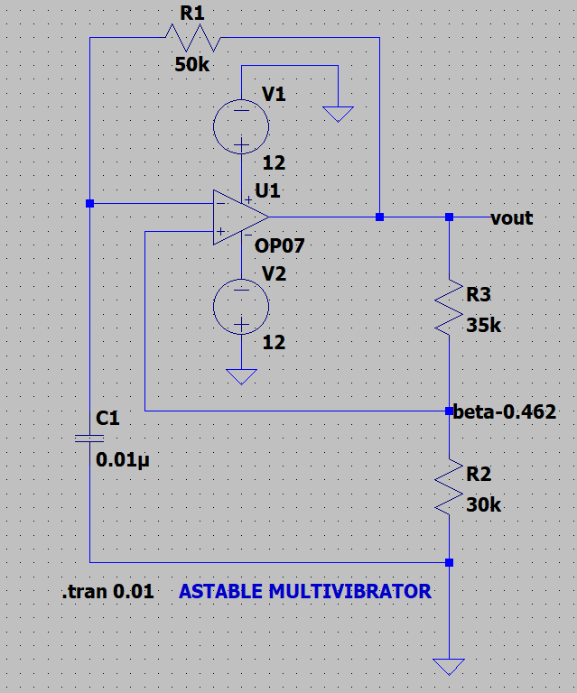

Output: -

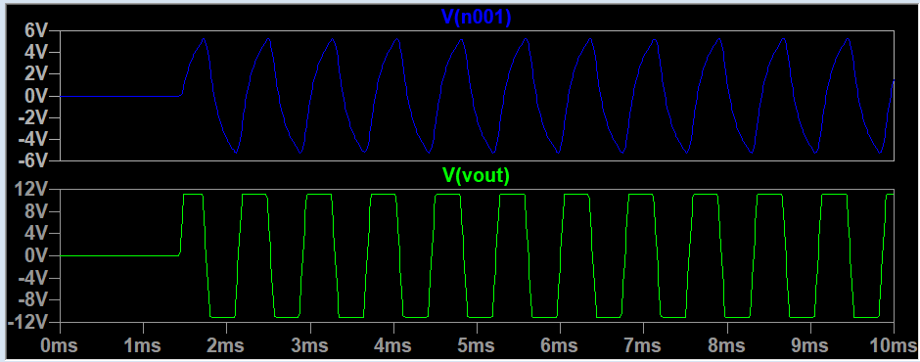

VARIABLE MULTIVIBRATOR: -

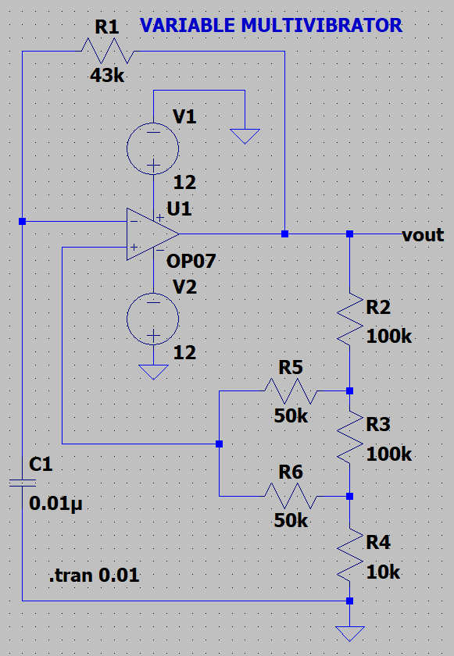

Output: -

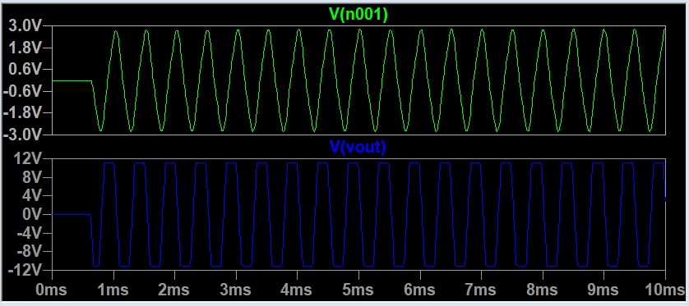

**RESULT: -**

**Thus, square wave generator and variable multivibrator is designed, tested and verified using LTSPICE.**